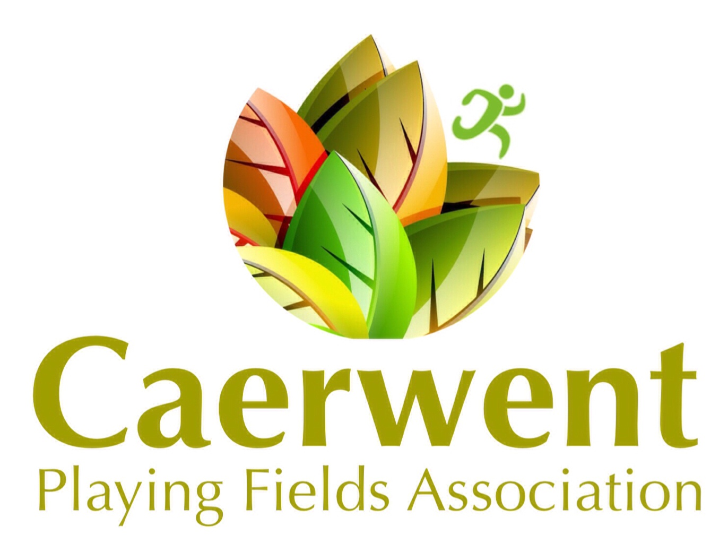**Caerwent Village Hall Booking Form** 

Application for the use of the village hall must be made on the booking form.

|  |  |  |  |  |  |  |  |
| --- | --- | --- | --- | --- | --- | --- | --- |
| Booking Reference |  | | | | | | |
| Name |  | | | | | | |
| Address |  | | | | | | |
| Telephone Number |  | | | | | | |
| Email Address |  | | | | | | |
| Start date of Hire |  | | Finish date of Hire | | |  | |
| Start time of Hire |  | Finish time of Hire | |  | Total Hrs | |  |
| Purpose of Hire |  | | | | | | |
| Approximate Numbers Attending |  | |  | | |  | |
| Facilities needed | Hall  Yes/No | | Kitchen  Yes/No | | | Bar Area  Yes/No | |
|  | Tables  Yes/No | | Chairs  Yes/No | | | Licensed Bar  Yes/No | |
| Facilities you will provide | Food Preparation  Yes/No | | Own Music  Yes/No | | | Own Bar  Y/N *** | |
| Payment Method (Please circle) | Cash | | Cheque | | | PayPal | |
| Hire Total Hrs | 0 | |  | | | BACS | |
| Hourly Rate | £0 | |  | | |  | |
| Total Hire Price | £0 | |  | | |  | |
| Refundable Deposit (to be returned with this booking form) | £0 | |  | | |  | |
| Total Hire cost (to be returned with this booking form) | £0 | |  | | |  | |

***NB The Hirer is to inform CPFA if it is proposed that alcoholic drinks are to be available at the event. No retail sale of alcohol may be undertaken by the Hirer except with the permission of CPFA the arrangements to be discussed and agreed by CPFA. Where CPFA so decides, the Hirer may be required by CPFA to apply for a Temporary Event Notice (TEN). Where a bar is provided an additional charge is levied as a contribution towards licence fees. A £500 refundable deposit is payable for all events where alcohol will be sold or served.

PERMISSION FOR 16TH, 18TH AND 21ST BIRTHDAYS MUST BE SOUGHT PRIOR TO BOOKING

Bookings can only be made by the return of this form with payment of the indicated fee

Please see our hire rates online [www.caerwentplayingfields.com/hire.html](http://www.caerwentplayingfields.com/hire.html)

Returning this form to the booking clerk confirms that you have read a copy of our Terms and Conditions of Hire and have understood them and agree to abide by them. Please ensure that if alcohol is to be served at your event you complete and sign the relevant section below.

**Signed Dated**

Cancellation of any hire agreement will be considered as per our terms and conditions which will be provided at the time of booking

**BOOKINGS CONTACT NUMBER 07455197139**

**POLICY ON ALCOHOL – VERY IMPORTANT**

CPFA holds a Premises Licence under the provisions of the Licensing Act 2003, as amended by the Mandatory Licensing Conditions Order 2010. Alcohol may be served in the Hall between the hours of 12.00 and 23.45 between Mondays and Saturdays and from 12.00 to 23.00 on Sundays. On Christmas Eve and New Year’s Eve the times are from 12.00 until 00.30. The Hirer shall observe the permitted licensable activities. A copy of the Hall Premises Licence and Mandatory Licensing Conditions Order 2010 may be viewed on line and in the Hall and the Hirer shall be deemed to have had notice of the permitted licensable activities. If the Hirer wishes to operate an event outside these licensable activities the Hirer may, with the prior agreement of the CPFA, apply for a Temporary Event Notice (TEN) for the event from Monmouthshire County Council.

NB AN APPLICATION MUST BE MADE TO CPFA FOR ALL 16TH, 18TH AND 21ST BIRTHDAY EVENTS PRIOR TO THE BOOKING BEING MADE. CPFA RESERVE THE RIGHT TO REFUSE CONSENT

Do you wish to apply for permission to sell/serve alcohol at your event?

YES / NO If yes:

[i] please complete and sign the declaration below; AND

[ii] please send the refundable deposit of £500 in the form of cash or cheque dated for the date of your event:

 The Hirer is to inform CPFA if it is proposed that alcoholic drinks are to be available at the event. No retail sale of alcohol may be undertaken by the Hirer except with the permission of CPFA the arrangements to be discussed and agreed by CPFA. Where CPFA so decides, the Hirer may be required by CPFA to apply for a Temporary Event Notice (TEN)

Only the Hirer is permitted to provide alcohol for the event, as agreed with CPFA. The Hirer is not to allow the provision of alcohol to be provided from any other source. No individuals are to be allowed to bring their own alcohol to the Hall without the consent of CPFA. Where such consent is granted, the Hirer will pay a deposit of £500 and will indemnify CPFA against the cost of any claims, damage or actions arising from any breach of the consent and all responsibility rests with the Hirer.

The Hirer is to ensure that, where alcohol is available, it is not served to anyone under the age of eighteen. Any breach of this regulation will result in forfeiture of the full deposit. In particular, as required by the Mandatory Conditions Order 2010, CPFA operates an age verification policy. This policy requires that the Hirer as the ‘responsible person’ must take proper precautions to prevent the serving of alcohol to anyone under the age of eighteen.

CPFA can provide alcohol and other drinks on a sale and return basis for events at the Hall. Guidance on the conditions concerning alcohol in the Hall, as required by the Licensing Act 2003 and amended by the Mandatory Licensing Conditions Order 2010, is available on request.

**Declaration**

I …………………………………………. (please print) as Hirer of Caerwent Village Hall for the above event, agree to abide by the conditions of the Licensing Act 2003, including the above conditions, and to comply with the Hall’s Age Verification Policy.

Signed  …………………………………………Date     ……………………………………..

**CAERWENT VILLAGE HALL - TERMS AND CONDITIONS OF HIRE**

**Village Hall Terms and Conditions**

These Terms & Conditions apply to all persons hiring Caerwent Village Hall as defined below. If there is any doubt as to the meaning of the terms and conditions set out in this document, then a member of the Caerwent Playing Fields Association Ltd should be consulted prior to the Period of Hire.

For the purposes of these conditions, the following terms shall apply:

“Hirer” shall mean an individual hirer or, where the hirer is a group or an organisation, its authorised representative who shall sign the booking form.

“CPFA” shall mean Caerwent Playing Fields Association, a company limited by guarantee and a registered charity

“The Hall” shall mean the whole building known as Caerwent Village Hall or any part of it (excluding for the avoidance of doubt the playing fields and the outdoor areas) agreed for hire in the hiring agreement.

All applications for hiring the Hall are to be in writing on the form provided and forwarded on completion to the Booking Secretary. The person by whom the application is signed shall be considered the Hirer. The Hirer shall be personally responsible for complying with these conditions and to ensure that the application accurately reflects the total period of hire, including any time deemed necessary by the Hirer in preparing the Hall for an event and clearing up afterwards.

The Period of Hire is defined as the date & time shown above or the time that the Hirer is actually in occupation of the Hall, whichever is the longer period.

Full payment for hire must be received within 5 days of the booking being taken. All bookings will be allocated a booking reference number. This number must be quoted in all communications. Please add a deposit payment of £500 if you are applying for permission to sell/serve alcoholic drink at your event (see below).

It is a condition of hire that a booking form is completed by the intended Hirer. If no booking form is received either in hard copy or electronically via the website, the CPFA have the right to cancel the booking at any time. Please make cheques payable to Caerwent Playing Fields Association.

This Agreement is made between the Hirer and CPFA as defined in this Agreement. The terms herein will constitute the whole agreement between the parties and any additional terms agreed between the parties must be noted within this agreement.

1.  BOOKING CONDITIONS

1.1 CPFA reserves the right to refuse any booking or to impose additional conditions. NB AN APPLICATION MUST BE MADE TO CPFA FOR ALL 16TH, 18TH AND 21ST BIRTHDAY EVENTS PRIOR TO THE BOOKING BEING MADE. CPFA RESERVE THE RIGHT TO REFUSE CONSENT

1.2 CPFA undertakes to make every effort to honour all confirmed bookings; however in the event of exceptional circumstances CPFA reserves the right to cancel a booking after advising the Hirer. No claims for any losses incurred by the Hirer as a result of such a cancellation will be considered.

1.3 The Hirer and those taking part in the function must comply with all directions given by the officers of the CPFA for the safety and security of the Hall, its contents and all persons using the facilities.

2.  PAYMENT

2.1 Please return the completed booking form with the requisite payment.   Cheques should be made payable to Caerwent Playing Fields Association Ltd.  Full payment for hire must be received within 5 days of the booking being taken and in any event full payment must be made before the event. CPFA reserve the rights to make an additional charge if the hall is not left clean & tidy. All bookings will be allocated a booking reference number. This number must be quoted in all communications.

3.  SUPERVISION:

3.1 The Hirer must take all reasonable precautions to ensure the safety and security of all parts of the Hall including, furniture, fittings and the fabric of the building.

3.2 The Hirer must exercise effective control at all times to prevent any dangerous or disorderly conduct*.*

3.3 The Hirer undertakes to appoint a sufficient number of competent persons, aged 18 or over, to provide adequate supervision throughout the hiring to ensure the provisions and stipulations referred to in the Hall conditions and any applicable licences are complied with.

4.       USE OF PREMISES:

4.1 The Hirer shall not use the premises for any purpose other than that described in the hiring agreement and shall not sub-hire or use the premises or allow the premises to be used for any unlawful purpose or in any unlawful way, nor do anything or bring onto the premises anything which may endanger the same or render invalid any insurance policies in respect thereof.

 5.  CARE OF PREMISES AND PROPERTY:

5.1 No application will be accepted from any person under the age of 18.

5.2 The Hirer will be responsible for any damage, loss or breakages caused to the building or its contents during the letting.

6.  LIABILITY:

6.1 CPFA accepts no responsibility or liability in respect of damage to, or loss of, any property or items whatsoever placed in or left on Hall premises, including the car park.

6.2 CPFA accepts no liability for any injury sustained by the Hirer, his/her guests or other persons attending the function for which the premises have been hired.

7.  ACCESS BY CPFA MEMBERS:

7.1 CPFA reserve the right, if and only if deemed necessary, to enter the Hall at any time during the hire period.

8.  CONSUMPTION OF ALCOHOL:

8.1 If alcohol is to be sold during any function, the Hirer must complete and sign the relevant section of the Booking Form indicating their agreement to abide by the conditions of the Licensing Act 2003 and the Hall’s own conditions.:

8.2 The Hirer must inform CPFA if it is proposed that alcoholic drinks are to be available at the event. No retail sale of alcohol may be undertaken by the Hirer except with the permission of CPFA the arrangements to be discussed and agreed by CPFA. Where CPFA so decides, the Hirer may be required by CPFA to apply for a Temporary Event Notice (TEN).

8.3 Only the Hirer is permitted to provide alcohol for the event, as agreed with CPFA. The Hirer is not to allow the provision of alcohol to be provided from any other source. No individuals are to be allowed to bring their own alcohol to the Hall without the consent of CPFA. Where such consent is granted, the Hirer will pay a deposit of £500 and will indemnify CPFA against the cost of any claims, damage or actions arising from any breach of the consent and all responsibility rests with the Hirer.

8.4 The Hirer is to ensure that, where alcohol is available, it is not served to anyone under the age of eighteen. Any breach of this regulation will result in forfeiture of the full deposit. In particular, as required by the Mandatory Conditions Order 2010, CPFA operates an age verification policy. This policy requires that the Hirer as the ‘Responsible Person’ must take proper precautions to prevent the serving of alcohol to anyone under the age of eighteen.

8.5 CPFA can provide alcohol and other drinks on a sale and return basis for events at the Hall. Guidance on the conditions concerning alcohol in the Hall, as required by the Licensing Act 2003 and amended by the Mandatory Licensing Conditions Order 2010, is available on request.

8.6 Age Verification Policy: The Hall’s Age Verification Policy is posted on the Hall Notice Board and in the bar next to the serving area.  A copy will be supplied to any Hirer who has requested permission to sell alcohol at their event. The Premises Licence will be available for viewing in the Hall and on line on our website.

8.7 CPFA will not allow the sale or provision of alcohol at children orientated events, e.g. Children’s Birthday Parties. If hirers wish to provide alcohol to over 18’s attending the event they must ensue they comply with 8.2 & 8.3 of these conditions and notify the CPFA of this proposal.

9.  GAMING, BETTING & LOTTERIES

9.1 The Hirer shall ensure that nothing is done on or in relation to the premises in contravention of the law relating to gaming, betting and lotteries.

10.  REMOVAL OF PROPERTY

10.1 Property belonging to the Hall must not be removed from the premises under any circumstances. No equipment is to be taken outside the building except by specific approval of CPFA or their agents.

11.     MAXIMUM NUMBER

11.1 The Hirer must ensure that the number of persons attending the event will never exceed 120 persons.

12.  FIRE SAFETY PRECAUTIONS:

12.1 The Hirer shall be given a copy of the document entitled “Fire Precautions & Fire Evacuation Procedures”, and undertakes to comply with its provisions, which form part of the Terms and Conditions of hire.

12.2 All parts of the Hall are No Smoking areas.

13.  SAFETY OF ELECTRICAL EQUIPMENT:

13.3 All electrical equipment brought into the Hall by the Hirer must comply with current electrical safety standards.

14. CAR PARKING:

14.1 Parking facilities are limited and it is advisable to ensure that cars are parked in an orderly manner to ensure maximum usage.

14.2 The speed limit in the car park is 5 miles per hour.

14.3 Parking is at owners risk. CPFA accepts no responsibility for loss or damage caused to vehicles or their contents.

15. HEALTH, SAFETY & FOOD HYGIENE:

15.1 The Hirer shall, if preparing, serving or selling food, observe all relevant food, health and hygiene legislation and associated regulations.

15.2 The Hirer shall ensure that no animals (including birds and reptiles) except Guide Dogs are brought into the building, other than with special approval of CPFA. At no time shall animals be allowed to enter the kitchen.

16. ACCIDENTS & DANGEROUS OCCURRENCES:  (Please refer to the Health & Safety folder, a ring binder located in the kitchen)

16.1 The Hirer must report all accidents involving injury to the public to a member of the CPFA as soon as possible and complete an Accident Form which can be found in the Health & Safety folder.

16.2 Further advice on the reporting of accidents can be found in the Hall’s Health, Safety & Fire Policy “Procedure in Case of Accidents”.  The Policy is in the Health & Safety folder.

16.3 Children are not allowed to enter the kitchen at any time.

16.4 Any spillages must be cleared up immediately to prevent accidents.  Equipment for this can be found in the kitchen.

16.5 Tables and chairs must be stacked carefully and not above chest height.  Trolleys are available to move heavy equipment, e.g. multiple chairs.

16.7 The Hirer must take full responsibility for First Aid cover.

17. COMPLIANCE WITH LEGISLATION & LICENCES

17.1 It is the Hirer’s responsibility to obtain any relevant licenses and insurances and to abide by the terms of them.

17.2 The Hirer must ensure that the number of persons attending the event will comply with relevant licenses.

17.3 The Hirer must ensure that they have the right to perform any copyright material. By signing the booking form the Hirer indemnifies CPFA against any liabilities for infringement of copyright.

17.4 Compliance with the Children Act 1989: The Hirer shall ensure that any activities for children under eight years of age comply with the provisions of The Children Act of 1989 and that only fit and proper persons who have passed the appropriate Criminal Records Bureau (CRB) checks have access to the children. Checks may also apply where children over eight and vulnerable adults are taking part in activities. The Hirer shall provide CPFA with a copy of their CRB check and Child Protection Policy on request but in all cases the Hirer agrees to assume sole responsibility for the safety and well-being of any children and vulnerable adults attending their events.

18. NOISE AND NUISANCE

18.1 The Hirer must ensure that nothing is done that will cause nuisance or annoyance to the occupiers of properties in the vicinity of the Hall. Hirers need to acquaint themselves and observe the licensed hours of the hall for the various activities. A copy of our licence is on display in the hall and will be available on line.

18.2 The Hall must be vacated by midnight unless permission for later use has been sought from and granted by the Committee.

19. TIDYING THE HALL AFTER USE

19.1 All parts of the Hall must be left in a clean and tidy condition and the Hirer is requested to ensure that the condition of the Hall as far as possible is left as found on arrival. All rubbish should be placed in appropriate refuse bags and taken away by the Hirer. Nappies must not be left in any area within the Hall including within any bins.

20. PUBLIC SAFETY COMPLIANCE:

20.1 The hirer shall comply with all conditions and regulations made in respect of the premises by the Local Authority, the Licensing Authority, the Hall’s policies or otherwise in connection with any event which constitutes regulated entertainment, at which alcohol is sold or provided or which is attended by children.

21. CANCELLATION

The Hirer agrees to the following cancellation refund policy in the event of the Period of Hire having to be cancelled

Cancellation within 7 days of event no refund

Cancellation within 4 weeks of event 25% refund

Cancellation within 8 weeks of event 50% refund

Cancellation 12 weeks or more before event 75% refund